- Which of the following is NOT a property of the yeast strain used for the functional assay?
- It lacks a functional MSH2 gene
- It is auxotrophic for tryptophan
- It is dependent on histidine
- It contains a functional URA3 gene
- None of the above

- The potent drug, 5-FOA is used for this assay because
- the URA3 gene combines with it to produce a color change
- it can be converted into a toxic form (5-FU) by an enzyme coded for URA3
- it is able to make transformed yeast cells grow
- it does all of the above

- Which of the following statements is true about the pRS413 plasmid?
  - It may contain WT or Mutant allele of MSH2 gene
  - It contains His3 gene that rescues the yeast strain from His dependence
  - It contains antibiotic resistance gene that allows for selection of plasmid-containing bacteria during cloning
  - All of the above are true
  - Only A and B are true

- The freezing step in the protein extraction protocol helps to
  - Put the yeast to sleep so that the detergent can work.
  - Break open the yeast’s cell
  - Cool down the temperature of the yeast cells considerably to avoid death before protein extraction.
  - Prevent protein degradation prior to protein extraction
  - All of the above.

5. The yeast utilized in the second phase of your project is
- Candida Albicans
- Saccharomyces cerevisiae
- Zygosaccharomyces
- Escherisia coli
- Cryptococcus neoformans

6. When a yeast cell has homologous pairs of chromosomes it is said to be
- Haploid
- Autologous
- Heterologous
- Diploid
- Mutated

7. In our yeast model, MSH2 activity was due to a gene expressed from:
- Yeast genome
- Yeast membrane
- pRS413 plasmid
- pSH44 plasmid
- Culture plate

8. In Genetic Nomenclature his3⁻ means:
a. we are dealing with a protein, specifically an enzyme synthesizing histidine
b. we are looking at a recessive his3⁻allele, in yeast requiring histidine
supplementation in media
c. it is a dominant gene allele
d. wild type gene coding for a histidine synthesizing enzyme

9. Growth of yeast colonies on the SD-his-trp plate indicates that:
a . msh2 mutant is benign
b. the URA3 gene is functioning and metabolized 5-FOA
c. yeast were successfully transformed with either one of the plasmids
d. yeast were effectively transformed with both pSH44 and pRS413 plasmids
e. msh2 allele was expressed and pathogenic

10. Which of the following statements is true about different plates we used:
a. YPD plate was used to select for successful yeast transformants
b. we used SD-his-trp plate to determine whether msh2 allele is functional
c. we used FOA plate to see if functionality of the MMR can be restored by WT msh2 allele found on the plasmid
d. A and C are true
e. none of the above are true

11. Mutation in which one of the domains of the MSH2 may result in a non-functional protein:
a. the protein binding domain
b. the DNA binding domain
c. the ATPase domain
d. structural integrity residues (throughout the protein)
e. all of the above

12. Based on your knowledge of the cell cycle and MSH2 function, which part of the cell cycle is this protein active in?
a. M phase
b. S phase
c. G1 phase
d. G2 phase

13. Organize the following protocols completed during this semester in the order in which they were performed in class:
Protocols: A. Yeast transformation
B. PCR amplification
C. plasmid isolation
D. FOA Complementation assay
E. Protein extraction from yeast
F. Restriction analyses
G. Selection of transformants
H. DNA gel electrophoresis
I. Protein gel electrophoresis

- I, H, G, A, B, D, E, C, F
- C, B, F, H, A, G, D, E, I
- A, B, C, D, E, F, G, H, I
- I , F D, C, A, G, H, E, B
- C, B, H, F, G, A, E, D, I

14. In PAGE analysis we used a certain agent to help us give proteins charge and denature them, the name of the agent is:
a. Ethidium Bromide
b. B-mercaptoethanol
c. sodium dodecyl sulfate
d. dithiotreitiol

15. To transform yeast means to:
a. Convert one strain of yeast into another
b. Introduce foreign DNA into a yeast cell, which is inherited and expressed
c. Add an antibiotic to the growth media to allow for survival of one strain of yeast
d. Insert a gene into a specific yeast strain that can only be copied but NOT expressed

16. Open Reading Frame (ORF) for a gene represents
a. Complete set of expressed sequences (exons)
b. Complete set of intervening sequences (introns)
c. Combined set of introns and exons
d. Complete set of amino acids
e. Product of the gene replication

17. Which of these internet links is best suited for obtaining a complete nucleotide sequence (both introns and exons) for the human MSH2 gene:
a. Google
b. Wikipedia
c. Pubmed
d. Yahoo
e. Biology Workbench

18. During which biological event is base substitution mutation most likely to occur in the cell?
a. Transformation
b. Bulk sequence deletion
c. PCR
d. Replication
e. Translation

19. Yeast constitutes a great model organism for molecular studies because:
a. They are simple prokaryotic organisms with a lot of similarities to human cells
b. Even though their genome is not fully sequenced we know it is small and
simple.
c. They can exist in a haploid or diploid form, are simple to manipulate, and
recapitulate all key cellular processes observed in a eukaryotic cell
d. They multiply by budding or direct division

20. Using SDS-PAGE is a technique used to:
a. quantify the amount of proteins present in a sample
b. can be used as a step in western blotting or immunoprecipitation
c. separate proteins based on their size
d. Only A and C are true
e. All of the above are true

21. The main reason we used beads in the immunoprecipitation protocol was to:
a. destroy all the cellular organelle and release proteins form them
b. help us isolate protein of interest from the protein extract
c. evenly distribute yeast transformants on the surface of the SD-his-trp plate
d. unfold the secondary and tertiary structure of proteins prior to PAGE analysis

22. Hallmarks of a cancer cell include all of the following EXCEPT:
a. ability to go through cell cycle check points without proper DNA repair
b. ability to avoid apoptosis
c. ability to promote formation of new blood vessels
d. ability to differentiate into a specialized cell
e. ability to invade local tissues and metastasize

23. Major source of restriction enzymes are...:
a. liver cells
b. pancreatic cells
c. bacterial cells
d. B cells
e. yeast cells

24. Which of the following should NOT be included in an abstract of a paper?
a. hypothesis
b. acknowledgements
c. summary of methods
d. summary of results
e. conclusions

25. Two strands of DNA are held together by which of the following?
a. peptide bonds
b. van der waals interactions between neighboring bases on the same strand
c. hydrogen bonds between the bases of anti-parallel strands
d. covalent bonds
e. all of the above

26. You have a 20 X solution of Coomassie blue in your laboratory. You need to stain protein on several PAGE gels so you need to prepare 250 mL of 1X Coomassie blue solution. How much of the 20X solution do you add to water to make your 1x solution?
a. 12.5 mL
b. 12.5 uL
c. 25 mL
d. 10 mL
e. 250 mL

27. What is the difference between agarose gel and polyacrylamide gel?
a. agarose gel is made from agarose while polyacrylamide is a mix of acrylamide and bisacrylamide
b. you can melt the agarose gel (and pour it again) but not polyacrylamide
c. agarose gel is ran horizontally, polyacrylamide is vertical
d. we used agarose gel to separare DNA and polyacrylamide to separate protein
e. all of the above are true

28. When designing mutagenic primers we wanted to achieve the following goals:
a. introduce a silent mutation into the MSH2 gene
b. introduce a nonsense mutation into the MSH2 gene
c. introduce a missense mutation into the MSH2 gene
d. alter a restriction site
e. both C and D are true

29. What is the difference between immunoprecipitate samples and protein extract samples we prepared?
a. protein extracts contain mainly MSH2 mutant protein
b. immunoprecipitate samples contained only MSH2::HA and antibody c. protein lysates contained all proteins found in the yeast cells
d. B and C are true
e. A and B are true

30. Gene categories important for cancer development include:
a. proto-oncogenes which normally act to promote cell death
b. tumor suppressor genes which when damaged are not able to regulate cell growth
c. genome stability genes which are responsible for repairing DNA damage
d. A and B are true
e. B and C are true

31. Repetitive (microsatellite) DNA regions are usually more unstable and prone to mutations because:
a. DNA polymerase tends to slip and insert the wrong nucleotide base as it makes the new DNA strand in this region
b. RNA polymerase cannot read the sequence properly in this region of DNA
c. They are not a part of the coding sequence in a gene
d. They are not a part of a normal chromosome

32. Major gene defect associated with HNPCC which was the focus of our project was:
a. nonsense mutation of mismatch repairs
b. suppression of tumor genes
c. activation of mismatch repair genes
d. missense mutation in the MSH2

Looking at the Figure 1 below state if the following statements are true or false:

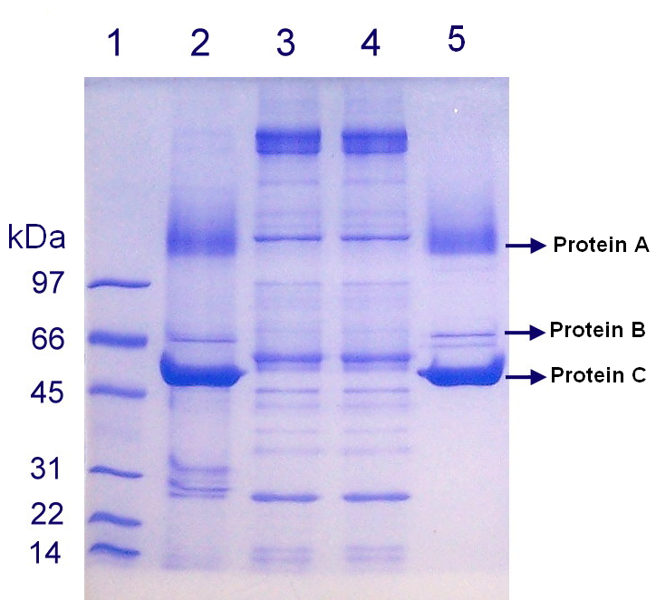

Figure 1. Image of gel electrophoresis.

33. T F The above gel is an example of an SDS-PAGE gel.
34. T F There is less of Protein C than Protein B.
35. T F Lane 3 visible on this gel contains the protein standard.
36. T F Approximate size of Protein B is about 66 kDa.
37. T F Lane 2 contains more Protein C than lane 5.
38. T F kDa next to the standard lane stands for number of amino acids.
39. T F Protein A is larger in size than Protein C.

40. Which one of the lanes above is most likely to contain an immunoprecipitation sample?
a. Lane 1
b. lane 2
c. lane 3
d. lane 4
e. lane 5

41. In eukaryotes, MSH2 binds with either MSH3 or MSH6 to form:
a. MutSα or Mutβ Heterodimers
b. MSH Homodimers
c. PMS1 Heterodimer
d. MutS Homodimer

42. Part of the coding sequence of a gene is AAGGTCCTC. How many nucleotides does it code for in the messenger RNA for a gene? How many amino acids does it code for in the protein?
a. 9 nucleotides and 9 amino acids
b. 9 nucleotides and 3 amino acids
c. 3 nucleotides and 9 amino acids
d. 3 nucleotides and 3 amino acids

43. Polymerase chain reaction (PCR) is:
a. a way in which cells can increase the amount of mRNA
b. a means of amplifying the amount of DNA in a cell
c. a means of amplifying a specific segment of DNA in the lab
d. a nuclear reaction that leads to mutations in microsatellite DNA
e. a way to cut out a specific part of the gene from DNA strand

44. A mutation that results in the formation of a stop codon and subsequent premature termination of protein synthesis is a:
a. Missense mutation
b. Frameshift mutation
c. Silent mutation
d. Nonsense mutation
e. point mutation

45. Based on the plate in Figure 2 we can say that:
- MMR is restored by the Empty Vector containing yeast
- URA3 is not expressed in the yeast containing WT MSH2
- 5-FOA was converted to 5-FU in WT MSH2 containing yeast
- None of the above are true

46. Based on the Figure 2 we can also surmise that:
a. Mutant MSH2 was able to completely restore MMR functionality
b. Since we are able to see some yeast colonies in areas spotted with yeast containing WT MSH2 plasmid, WT MSH2 is mutated as well
c. Mutant MSH2 was NOT able to restore functionality of MMR in yeast
d. Mutant MSH2 was able to ONLY PARTIALLY restore the MMR functionality

FOA plate
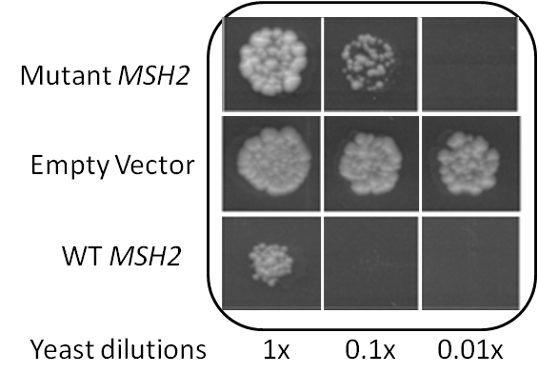

Figure 2. Picture reveals results of the 5-FOA complementation assay. 5-FOA plate was spotted with yeast transformed with plasmids containing either Wild Type MSH2, Mutant MSH2 or with an empty plasmid and incubated for 72 hrs at 30°C.

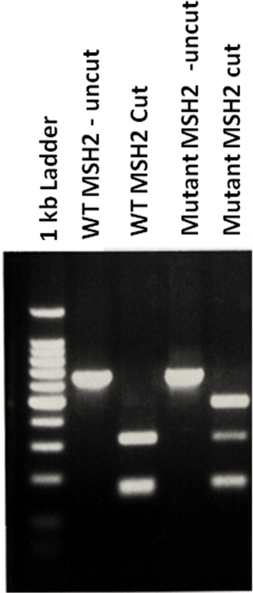

Figure 3. Image represents 2 % agarose gel electrophoresis of DNA samples following enzyme restriction analysis with BstYI enzyme.

47. Based on Figure 3 we can say that:
- Enzyme restriction worked
- Mutant MSH2 contains an extra restriction site
- Mutant MSH2 sequence differs from WT MSH2
- Only A and B are true
- All of the above are true

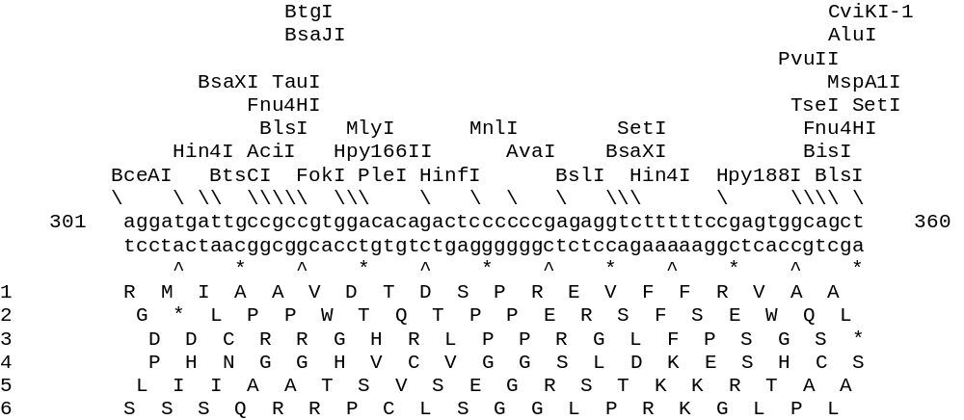

Figure 4. Linear Enzyme Restriction Map

Table 1. Total Number of Hits per Enzyme and Specific Sequence Recognized by each Enzyme:

Enzyme name | Number of cuts | Restriction sequence
AciI | 15 | C'CG_C
AluI | 6 | AG'CT
AvaI | 4 | G'GwC_C
CviKI-1 | 19 | rG'Cy
HinfI | 3 | G'AnT_C
Hpy188I | 8 | TC_n'GA
MaeIII | 6 | 'GTnAC_
MspA1I | 1 | CmG'CkG
NciI | 7 | CC's_GG
NotI | 1 | GC'GGCC_GC
PmlI | 1 | CAC'GTG
PspOMI | 2 | G'GGCC_C
SetI | 14 | _AssT'

48. Using information from Figure 4 and Table 1 Identify the enzyme that cuts in 6 places and creates blunt ends:
- CviKl-1
- Ncil
- Alul
- Pmll
- Acil

49. Based on Figure 4 and Table 1 Identify the enzyme that generates sticky ends, cuts the sequence in 3 different locations:
- MaeIII
- HinfI
- MspA1I
- NotI
- AciI

EXAMINE the sequence below and answer questions:

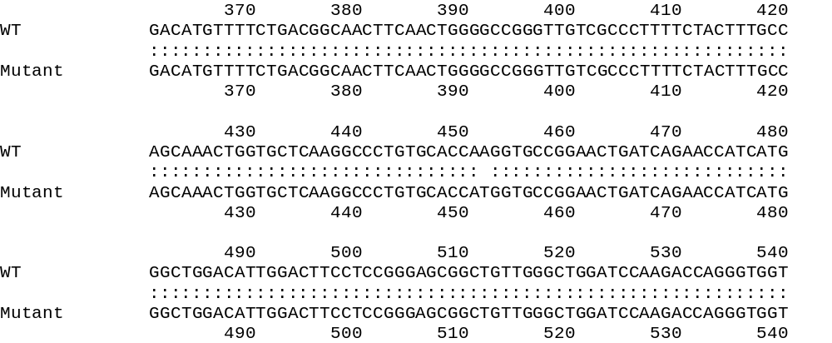

Figure 5.

50. The above Figure 5 shows:
- An ORF – a result of SIXFRAME analysis
- A linear enzyme restriction map
- an alignment of amino acids
- an alignment of nucleotides
- codon sequence

51. Based on the Figure 5 provided above we can say the following about the mutation:
- Mutation converts T to A
- This is a missense mutation
- This is a base pair substitution
- This is a silent mutation
- This is a frameshift mutation

WT PQDASTKKLSECLKRIGDELDSNMELQRMIAAVDTDSPREVFFRVAADMF
Mutant PQDASTKKLSECLKRIGDELDSNMELQRMIAAVDTDSPREVFFRVAADMF
**************************************************

WT SDGNFNWGRVVALFYFASKLVLKALCTKVPELIRTIMGWTLDFLRERLLG
Mutant SDGNFNWGRVVALFYFASKLVLKALCTMVPELIRTIMGWTLDFLRERLLG
*************************** **********************

WT WIQDQGGWVRLLKPPHPHHRALTTAPAPPSLPPATPLGPWAFWSRSQWCP
Mutant WIQDQGGWVRLLKPPHPHHRALTTAPAPPSLPPATPLGPWAFWSRSQWCP
**************************************************

Figure 6. Clustlaw alignment of a mutant and WT VIP sequences:

52. Based on the alignment in the Figure 6 we can say that the following mutation is:
- Mutation converts M to K
- This is a point mutation
- This is a nonsense mutation
- This is a missense mutation
- A and D are true

53. Based on the mutation in Figure 6 we can say that the protein activity …
a. is increased
b. is reduced
c. cannot be determined
d. is unaffected
e. is completely abolished

